SC Figure 1.10.0.7 — pushDeliveryComponent()
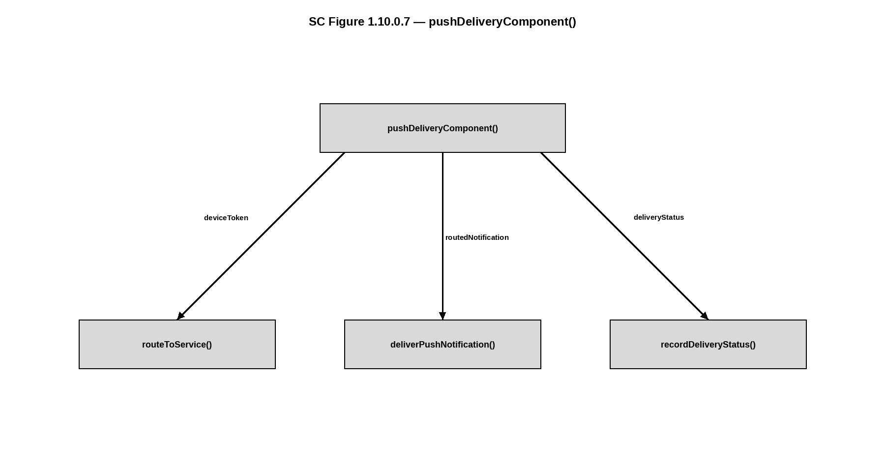

SC Figure 1.10.0.8 — newsFeedManager()
